Members: Daniil Blagoev, Jakub Jelínek, Rositsa nikolova, Rens van den Elzen

3/23/2022

Process Report

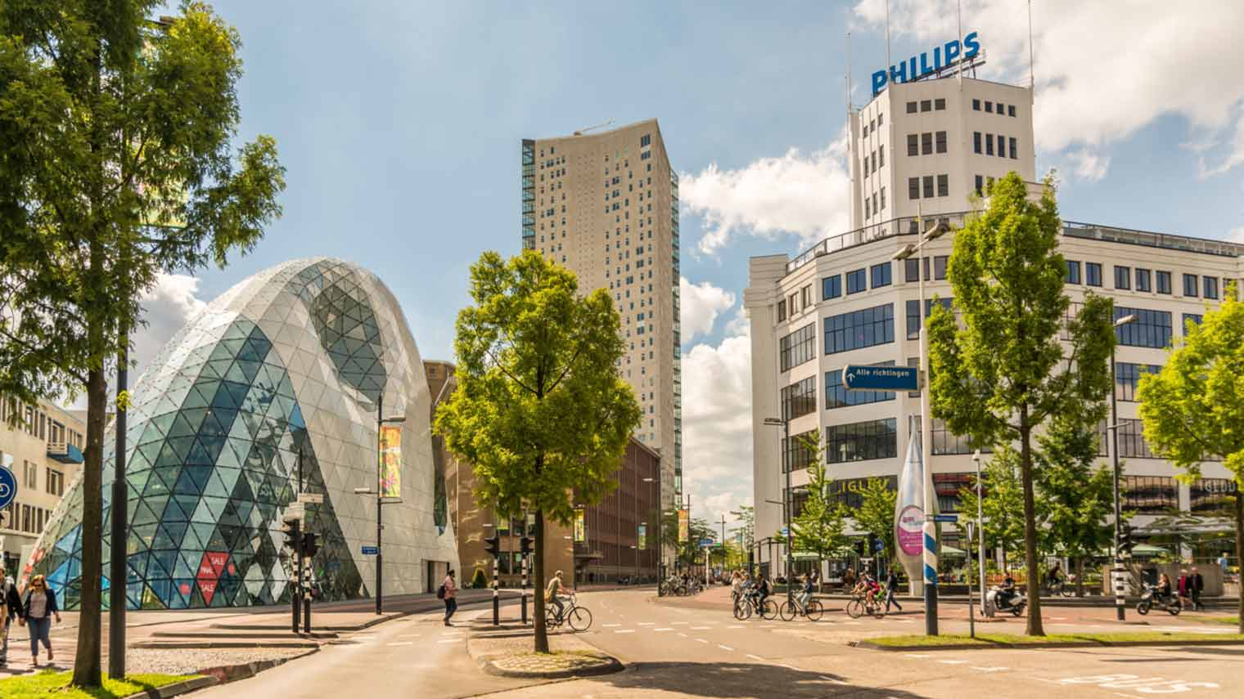

Location: Eindhoven

Tutor: Michiel Koehorst

Location: Eindhoven

Work division

Work division is one of the most important aspects of making a project idea and plan come into fruition. Assigning tasks in such a way that group members don’t feel like the workload is unfair and uneven is a big part of it. The tool which helped us with this was Jira. Here is a small snippet of what that looked like:

We did not have a person who directly handed out tasks to whoever they wanted, instead, everyone could choose what they would like to do most of the time.

## Personal reflection

#### Daniil

In my personal opinion, the project has been going pretty well. Sometimes it felt like there were mountains of work to be done but we managed to get through those points of struggle. The teamwork was on point, everyone in the team was open to new ideas and I feel like our coordination was spot on. Working with Rens, Jakub and Rositsa was not only a productive, but a fun experience as well. At times it seemed like we were struggling to keep up with the pace of the program, because of having to work on 2 projects at once, but I feel like we covered what we learned in class the past weeks well. Everyone put in a lot of effort, and I am proud of my teammates and what we managed to create for the time we had.

#### Rositsa

In my point of view this phase of the project was a challenge. All of us did not have prior experience with developing a software system for a client in so short period of time but I think, we managed to do well and covered all the basic requirements. The most important part of such projects is the communication – with the client and between the team members. In my opinion, we showed very good level of communication skills and understanding of the requirements. We followed strictly the guidance of our tutor and implemented the feedback after every meeting. Due to our weekly meetings we managed to further develop our hard and soft skills. I believe, our team is very united, and we decide everything together. Everyone had the opportunity to shine with his best qualities but also to step out of his conform zone and learn a lot. There was a room for discussion, everyone's ideas were considered. We managed to deal with huge amounts of work for short period of time and I am proud of that. Something that can be improved is splitting the time for the tasks better – more time for developing.

#### Jakub

From my personal view we have done lot of work. This project was not just about finishing or creating software solution for client, but also about team collaboration, problem solving and time management. I have to confess that it was not easy 5 weeks, however it had strengthened our mind and showed us how the real life projects look like. This whole project was so war very contributive for me, it has really widened my tunnel view in project management area which I am very grateful for. It is very good experience and I honestly couldn’t wished for better team.

#### Rens

The development of the project went fairly well in my opinion, teamwork went pretty fluent and the work was devided equally. I did at times feel like I was fixated on a specific part of the code to solve an error only to later find out that the problem was somewhere else entirely. On other times I felt like I saved the day when git started acting up. All in all a job well done.

## Reflection about applying Waterfall

#### Strengths

The strengths of the Waterfall method are in its definitive planning and outlining of processes that need to be done in order to complete the project. Pretty much everything is planned from beginning to end in it. It provides a clear plan and sequence of actions.

#### Weaknesses

The main weakness of the Waterfall method is the lack of flexibility in the development process. Since everything is planned beforehand, it may be problematic if an external event calls for a change of course during development. Another problem is that sometimes clients cannot clearly turn their needs into functional requirements, and it gets left up to the team to kind of guess exactly what needs to be done.